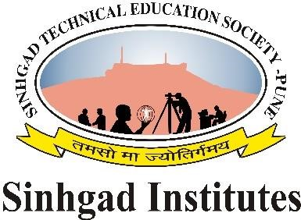

SINHGAD FORT / GHAT CLEANING CAMPAIGN REPORT
Activities Description.
Happy to share with you all, Sinhgad Institute's, Smt.Kashibai Navale College of Engineering, Women's Geievence Cell organized Half Day workshop on 'Self Defence', on 30th August 2019. Workshop inaugurated by Vice Principal Dr. K.R.Borole. Workshop conducted by Prof. S.M.Ingawale, Head Women's Geievence Cell and coordinated by Prof. Araddhana Deshmukh ( Computer Engineering Department) along with ACE member Pallavi Parnaik, Mrigakshi and committee. Workshop session conducted by Bhagyashree Pisal (Black belt 1st dan)
Supriya supekar (Black belt) . The world is changing there is a growing need for increased focus on self-defence and fitness. Bhagyashree provided many hints on "Self-defence should be taught to girls from a young age for their safety and protection, and it will surely help them evolve into stronger personalities. Moreover trainer also suggested for regular practice helps build determination, confidence, maintain physical and mental balance. It also helps overcome the high stress children face in their studies, gives strength and focus for an independent life, contributing to make our society better. Workshop attended by more than 60 girls of SKNCOE.
Women's Grievance Cell coordinated in SKNCOE by Prof. S.M.Ingawale (Head), Registrar Mrs. Kavita Borgave, Prof.Araddhana Deshmukh ( Comp) Prof. S.S. Jahagirdar (E &Tc ) , Prof. Saraswati Nagtilak ( IT), Prof. Dr. Sawant (FE), Prof. Shewane (Mech). Thanks to SKNCOE Principal Dr. A.V.Deshpande sir and all Head of Department of SKNCOE for
